  - fargo-Moorhead

INTERGROUp
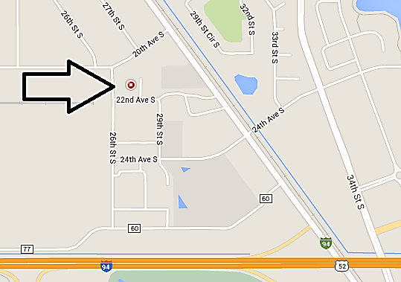
  - MEETING
1st Tuesday of the Month
6:00pm
Villards Auction House
2732 22nd Ave. S Moorhead MN

Help serve the FM community of Alcoholics Anonymous. Bring your group’s contribution to the Intergroup Conscious as we discuss and develop how we carry the message to the still suffering alcoholic.
For more information contact:
fargomoorhead.intergroup@gmail.com

